Executive Committee Office of CICAF
China National Youth and Children’s Palace Association
China Association for Children’s Plastic Arts

Notice

on 2020 China (Hangzhou) International Children’s Cartoon Contest

NOTICE is hereby given with respect to 2020 China (Hangzhou) International Children’s Cartoon Contest (ICCC), which is co-hosted by the Executive Committee Office of CICAF, China National Youth and Children’s Palace Association and China Association for Children’s Plastic Arts, executively operated by Hangzhou Youth & Children’s Center, and co-organized by People’s Association for Friendship with Foreign Countries of both Zhejiang province and Hangzhou. Kindly requested as follows is your attention to information necessary to know.
I. About ICCC
Since 2005 from the outset, China International Cartoon and Animation Festival (CICAF), the annual Hangzhou-based event is nowadays the largest and most popular gathering with great influence over the community of cartoon and animation. It is a part of China’s “Outline of the Program for Culture Reform and Development during the 12th Five-year Plan” and seen as a vital part in the “Go-Global Program for Chinese Culture”.

As a part of the Festival, ICCC is now 15 years old starting from 2006. The year-long event comprised of contests and exhibitions has been a pilgrimage for a total of 400,000 contestants from over 40 countries and regions. ICCC is also a stage for over 900 organizations and close to 100 groups working with foreign contestants, leaving behind over 50,000 copies in 14 series all about its prize-winning entries. ICCC calls for originality and proposes a theme for contestants every year from perspectives like the Chinese culture, the future, humanity and environment protection etc.. Cartoonists like Han Meilin, Zhu Deyong, Wong Yuk-long, Cai Zhizhong and Phil Ye (US) were the invited judges to the Contest that grants over 4,500 prizes classified for outstanding, gold, silver, bronze and excellent entries and tutors’ contributions. Now ICCC stands as a trademark event of CICAF most appealing to our next generation from both China and the rest of the world. Among the Chinese multi-national cultural activities of global reputation, it is also a giant stage for kids who love fine arts around the world.

As a session to ICCC, a biannual forum that focuses on “Collision, Fusion, Creativity — Cartoon & Animation Culture and Fine Arts Class for Kids” has been available since 2011 to have the presence of cartoonists, experts and teachers from the circle. The presentations, discussions and hands-on experiences combine the latest research with common practices and are open to the knowledge from the whole community, making the forum itself a propellant to both the performance of cartoon and animation teachers alike and the academic findings for the relevant education.

To further extend ICCC’s reach to the world, we launched a global entry tour, China exhibition and other projects in 2014. Over the past six years, a total of some 3,000 prize-winning works have been on display for over 80 such tours held in Malaysia, Germany, Japan, Russia, Canada, Singapore, Hungary, and Taiwan and main cities of the mainland.. To gain a new height for the global market, ICCC also unveiled 5 sites as its overseas venues in Malaysia, Japan, Canada, Singapore, UK and Germany.
II. Timeline
1. Early October 2019, kick-off of the Contest global solicitation
2. October 2019 - April 2020, organization of entries and promotional activities
3. February 20, 2020, deadline for submissions
4.March-April 2020, evaluation at initial, review and final stages; prize-winner unveiling; exhibition and award ceremony preparation; prize-winning entries collection compilation (ceremony details to be informed to the winners in early April.)
5. Early May 2020, prize presentation and entry exhibition during CICAF
6. End of June 2020, completion of issuance and delivery of certificates and prize-winning entry collections
7. May to the end of 2020, organization of 20 prize-winning works exhibition tours in China and worldwide.
III. Special Invitation
1. Availability to be the organizer of ICCC overseas contest. We will continue to call for the organization of ICCC overseas contests around the world. Application for organizing ICCC overseas contest shall be delivered to the Contests’ organizing committee should the applicants have such qualifications and intent.
2. Availability to be the organizer of entry exhibition tours in China. We will continue to select quality organizational contestants to stage 2020 exhibition tours in Chinese cities. Application for the staging of the tours shall be delivered to the Contest’s organizing committee should organizational contestants are qualified.
Please contact the ICCC organizing committee for more details: Wang Zhan (13336036997, also WeChat ID).

IV. Remarks
1. Admission to the Contest will be totally free of charge.
2. A prize for the organizers’ contribution will be available in the light of the number of entries and prizes granted.

3. Please see Appendix I for the notice inviting entries, Appendix II for the registration form for entries, and Appendix III for the statistics form for group contestants.


Executive Committee Office of CICAF (Seal)

China National Youth and Children’s Palace Association (Seal)

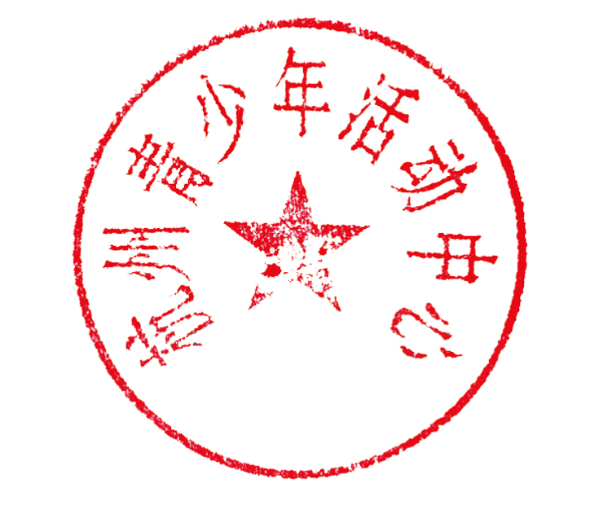

China Association for Children’s Plastic Arts (Seal)

Hangzhou Youth & Children’s Center (Seal)
Appendix I

CONTRIBUTIONS WANTED for
2020 China (Hangzhou) International Children’s Cartoon Contest

I. Name: 2020 China (Hangzhou) International Children’s Cartoon Contest
II. Co-hosts
Executive Committee Office of CICAF
China National Youth and Children’s Palace Association
China Association for Children’s Plastic Arts
III. Executive Organizer:
Hangzhou Youth and Children’s Centre
IV. Co-organizers:
Zhejiang Provincial People’s Association for Friendship with Foreign Countries
Hangzhou Municipal People’s Association for Friendship with Foreign Countries
V. Sponsors
Wit & Humor
Art Kingdom
Shandong Xinwencui Art Supplies Co., Ltd.
VI. Organizers of ICCC Overseas Contests
Artopia Education Trust (Malaysia)
Fukui International Association / Gifu International Exchange Association / Gifu Japan-China Cultural Exchange Association (Japan)
Singapore Sunshine Arts Education (Singapore)
Sino-UK Cultural and Educational Exchange Information Association (UK)
SINIKA Culture & Business Development GmbH (Germany)
VII. Contributors
Anyone under 18 years old worldwide (born after Jan. 1, 2002).
VIII. Theme (one option only)
- 5G era
- Garbage classification
- Passing on love
IX. Rules of the Contest
- Contestants shall be classified as the Teens (junior and senior middle school students) and the Kids (primary school students and preschoolers).
- Contestants shall attest and affirm the entry submitted to the Contest is an original work of the contestant himself/herself. All consequences arising from any infringement of the legal rights of others regarding the entries to the Contest shall be ascribed to and assumed by the contestant himself/herself. Any entry reportedly guilty of plagiarism shall be deprived of its qualification to be prize winners.
- Only ONE entry shall be allowed from each contestant.
X. Entry Specifications
- Only handmade works are acceptable. Neither submissions of color prints nor entries of 2 and more than 2 authorships are acceptable in the Contest.
- The entry shall be presented creative and positive in content and in any form, including the eligibility as single paper, four-panel, multiple-panel, strip cartoon, or any other innovative form. Single or multiple colors are both allowed. For a paper the entry, in no need of framing, shall be sized from 20×30cm to 40×55cm in limited specifications.
- Each entry shall be attached on the bottom right corner with a Registration Form for Entries (please refer to Appendix II) filled with neatly written information such as the author’ s nationality, name, gender, date of birth, classified group, name of school (or organization), mailing address, post code, phone number, tutor and entry title etc. To download the Registration Form of Entries and the Statistics Form for Group Contestants, please visit the official website of CICAF (http://www.cicaf.co) and that of Hangzhou Youth and Children’s Center (http://www.hzqsn.com).
XI. Prizes:
- 10 Outstanding Prizes (RMB 1,000 for each).
- Gold, Silver, Bronze and Merit Prize respectively granted to 1%, 1.5%, 2.5% and 5% of the total entries.
- In order to encourage young people to take an active part in the creation of comic story scripts, more prizes will be given to the four panels, multi panels, comic strips and other stories.
- An Excellent Organizer Prize granted to the contesting group contributing over 200 entries or as a high-proportioned prize winner.
- A Prize for Tutors’ Contributions granted to tutors of Outstanding and Gold Prize winners and directing tutors in the Excellent Organizer Prize winners.
- The contest will select excellent winning works into the collection of works, special prize, gold medal, counseling award, organization award winners will receive a collection of works.
XII. Exhibitions
Prize winners will be unveiled in early May on the website of CICAF and Hangzhou Youth and Children’s Center, and their entries will be on display in different forms, including a colored 12-page album of the Contest’s entries. The official website of the ICCC has set up an exhibition area to display the gold award works. Prize-winning entries will partly appear in magazines like Wit & Humor and Gamesky. The 7th Season of ICCC Exhibition Tour will be presented to the audience in the second half of 2020 in Canada, Japan, Malaysia, Singapore, Germany and UK. Exhibitions of prize-winning entries will be organized in different Chinese cities as well.
XIII. Agreement
No entry shall be returned. The author of the entry shall agree to transfer the rights of publication, exhibition and property ownership to the hosts and organizers of the Contest. All contestants shall be deemed to concur with the agreement above.
XIV. Deadline of Submissions
February 20, 2020 (the date on postage shall prevail)
XV. Address to Deliver
Cartoon Contest, Hangzhou Youth and Children’s Center, No. 22 Zhao Qing Si Li Street, Xihu District, Hangzhou, China (310007)
Contact Person: Wang Zhan Mobile: 13336036997 (also WeChat ID)
Phone (office): 0086-0571-85821035 (Closed on Monday / Tuesday)
Fan Zhenzhen 0086-0571-85828161 (Closed on Monday / Tuesday)
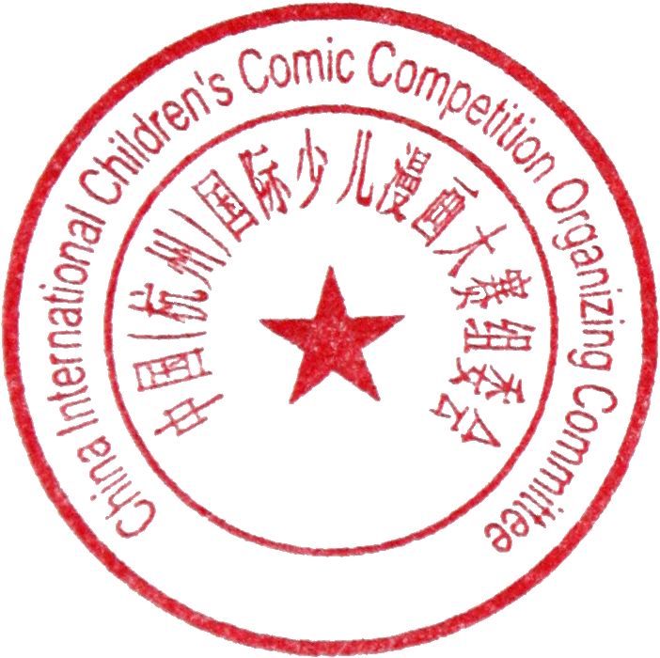

Organizing Committee of China (Hangzhou) International Children’s Cartoon Contest
October 20, 2019

